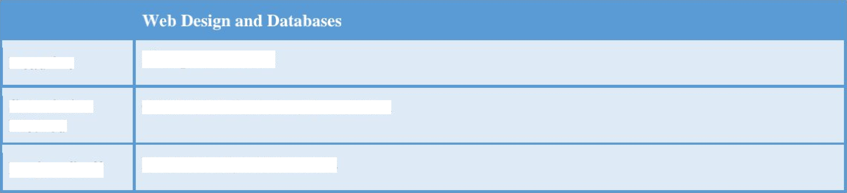
DeadGne
5° September 2025
Submivion
Melhod
CANVAS Submission, Presentation
Project Sta«r
Dr. Bello Aliyu Muhammad

    Unit Title | Web Design and Databases | Level / Term | Level S Term 1
Unit Code | CYS222l04 | Credit /  Weighting % | 20 Credits
Unit Leader | Dr. Bello Aliyu Muhammad | Date of Issue | 7^ July 2025

1

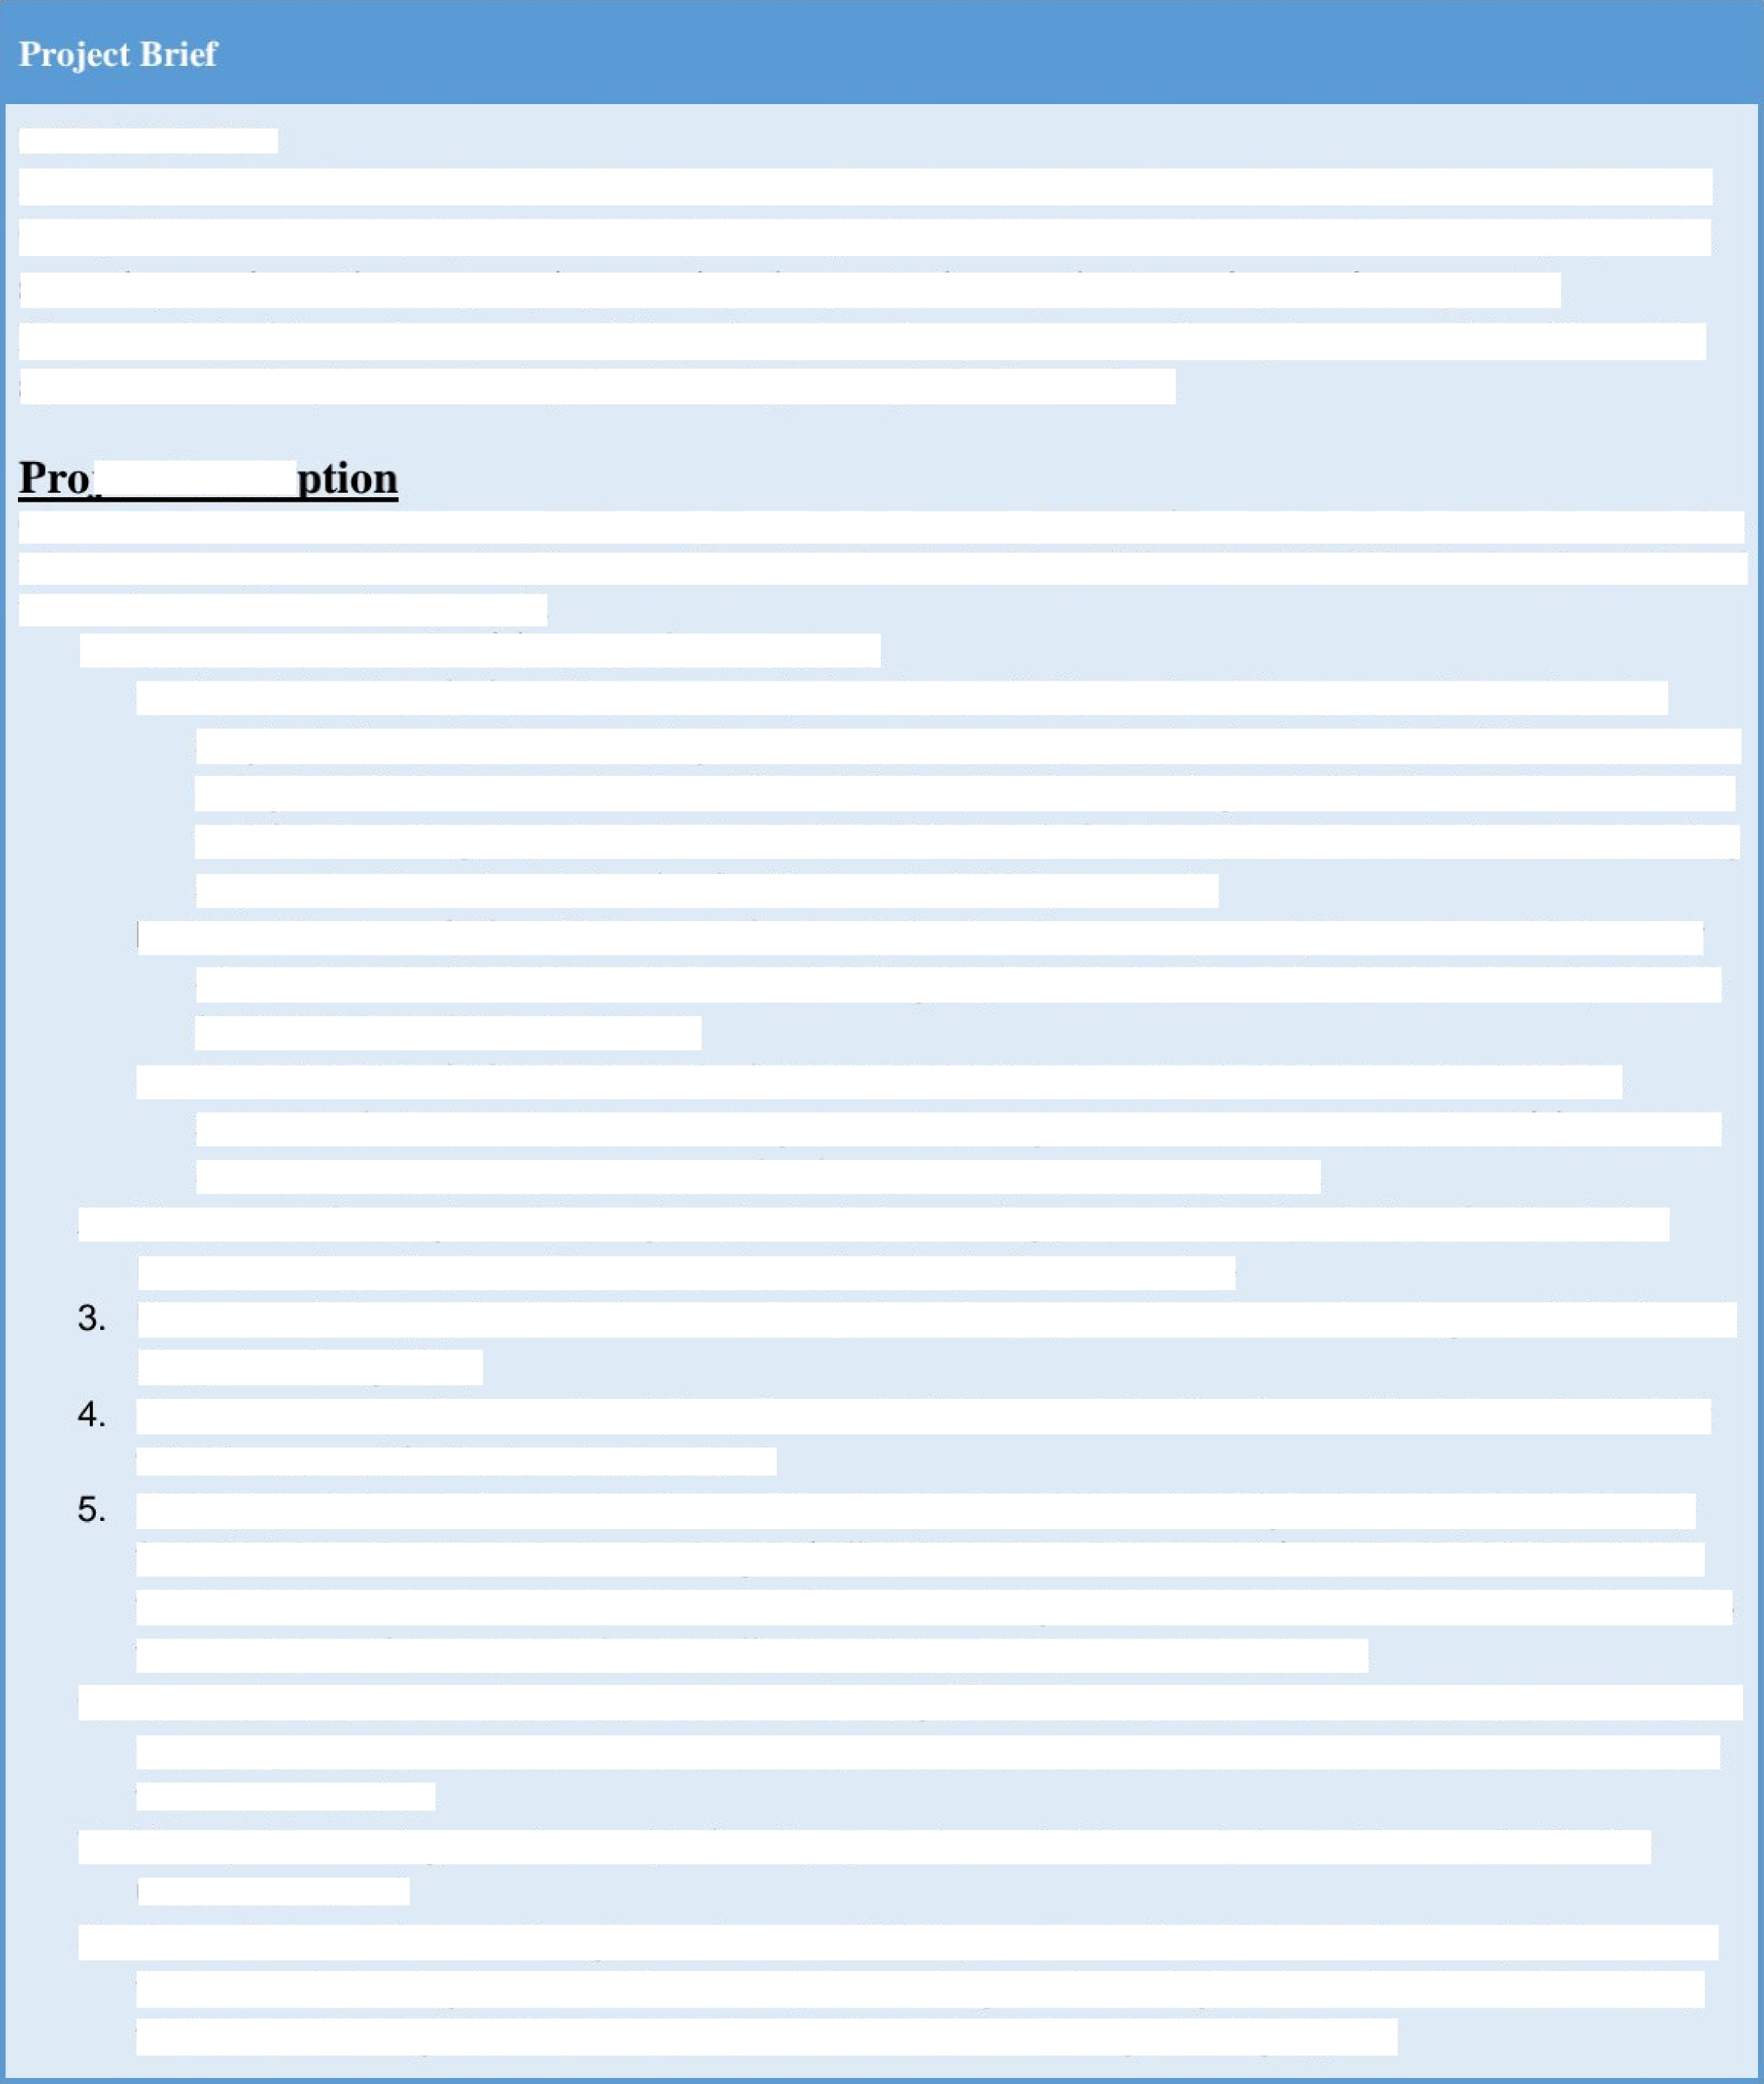
INTRODUCTION
As a professional in Web Design and Databases, a client, herein referred to as CheapFlix, has a job for you. CheapFlix is a new company ihat is coming io disrupt ihe market dominance of ie Netflix monopoly of ie steaming services. The company is proposing changes io ie way ie steaming services operaies.
Please read the job requiremenis carefully and produce ie system as par the requirements of the client. The system must be implemented using the technologies taught in ie module.
iect Descri

CheapFlix is a stream service startup kickstarting streaming services in the UK. It's services pretty much similar to Netflix where users pay and watch movies. However, CheapFlix aims to do things differently. The following is a description of the services and the rnodus operandi.
- There would be three (3) levels of subscription.
  - Level 1 subscription: Users can only view the available movies. The account is restricted to single device only. ‹r›nce you log into the account on a particular device, that's it. If the user wants to log into his/her account with a di0erent device, he/she must log out of the first device and must wait for 7 working days to make the switch. This level of subscription does not allow downloading any movie. The subscription fee for this level is £4.99 per month.
  - Level 2 subscription: This level of subscription has the same prescriptions as level 1; the only di0erence is that this level allows downloading any/all the movies available. The subscription fee for this level is £7.99 per month.
  - Level 3 subscription: This level of subscription has the same prescription as level 2. The additional feature however is allowing the users to log into their accounts with three (3) accounts at the same time. The subscription fee for this level is £9.99 per month.
- Users must first register. The registration includes putting personal details, choice of subssription

level as well as checkout. Users can also edit their details at any time
Users must also pay for their shosen subscription. The payment can be made using crediVdebit card, Paypal or GooglePay.
?›nce user has paid for a subscription, the card details are retained and saved for future direst debit
with the amount for the level subscribed.
Once payment is made, it is nonrefundable. If any user switches to a higher subscriptionlevel, say from level 1 to level 2, the top up charges (di0erence between the levels) is automatically deduced from the saved debit card on the account. If a user downgrades his/her subscription, say from level 3 to level 2, no refund is made for the di0erence in the price between the levels.
- The default currency of payment is Pound Sterling (GBP £); however, users can choose to pay in any acceptable surrency around the world. The system must be able to handle the conversions between the two currencies.
- The system must generate receipts for all payments made. The receipts must be emailed to the

users concerned.
- Cancellation notice must be given advance of 30 days or 1 month (whichever is closer). This means that a user intending to cancel his subscription on August 7’^{h} must give the notice from at least July the 7‘^{h}. Failure to give this notice would result continuous charges being applied

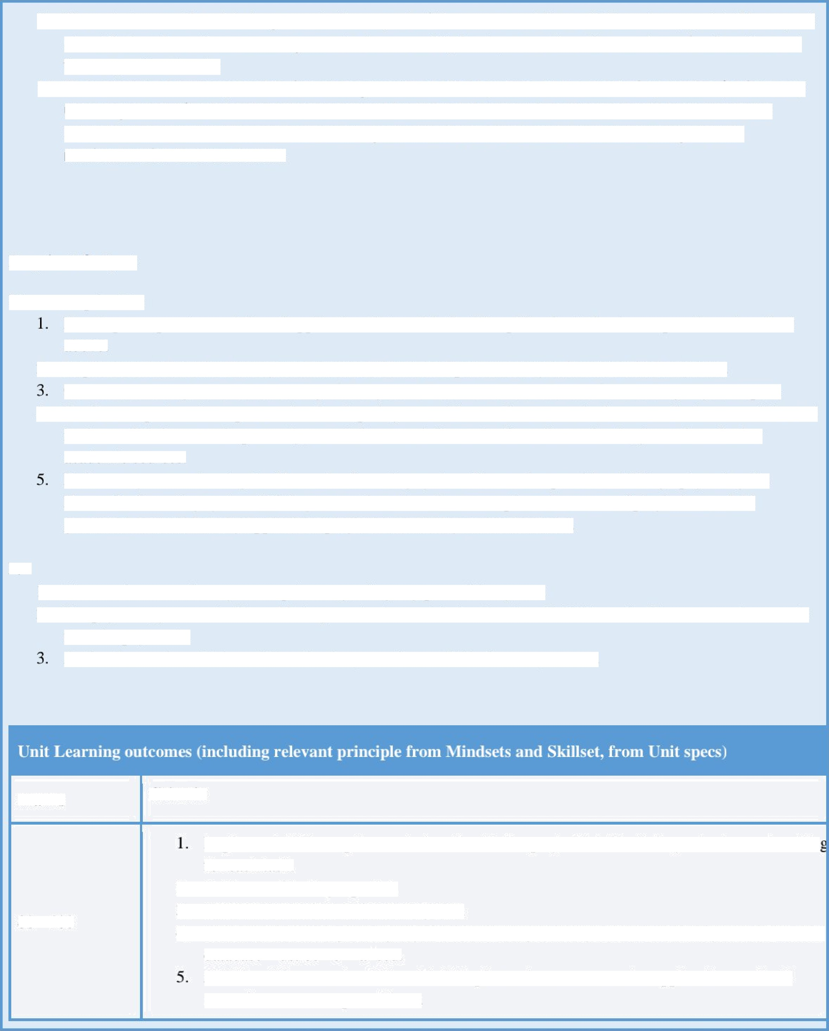
- The admin must be able to generate the repol of the users and the activities at any point. The report should also show the revenue generated on monthly basis, as well as the number of subscribers at the respective levels.
- The admin is also responsible for adding movies to the system. At the stal of operation (before any
user registration), all available movies must be added. However, movies would continuously be added to the system. Once a new movie gets added to the system, all users must get email notification for the new movie.

Required Output:
You are required to:
Develop a responsive web-based application that enable the CheapFlex for its business operations described
above.
2. Implement a robust database system that would store and process every infomation in the system.
Conduct a thorough and robust testing of the system. Document the evidence of this testing in your report.
4. Draft a comprehensive report on the developed system. You are free to use the lecture and other materials used in the module but most importantly, search for more information from the textbooks, journals and other academic sources.
Reference yow work using the Harvard referencing system. Please dso provide a bibliography using the Harvard referencing system. While you use the external sowces, please be aware of plagiarism and AI generated content. Penalty applied for plagiarism and AI generated content.

NB
- You are free to make any assumptions regarding any part of the system
- For payment, you can build a table in your database with simulated credit/debii cards. You can use these cards
to make payments.
As for the movies, obiain and download any movies available from any source.

Marks

80 - 100
Criteria

Implement all the requirements described in the project brief including robust error handlin for each task.
  - Evidence of testing reported.
  - Good user interface and usable system
  - Good database design using any database management system (DBMS) of your choice. The
database must be normdised.
Additional features should be added. Explore other stream service applications and add some features not captured here.


Ravensbourne
University Lc›ndz›n

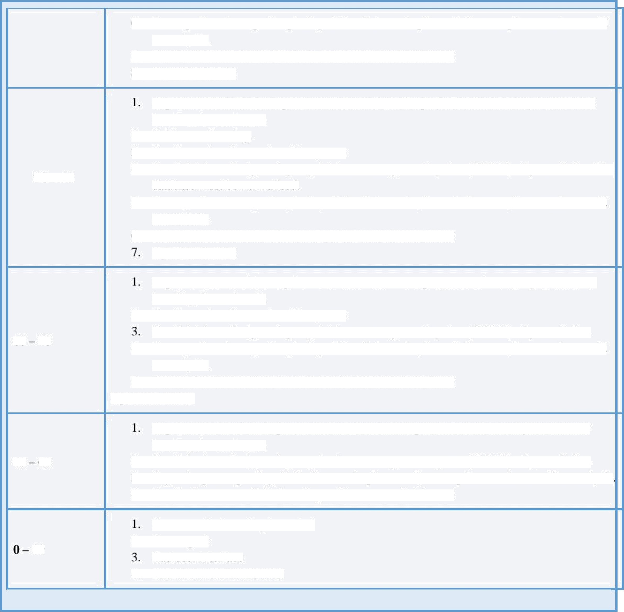
- A comprehensive report capturing all the features implemented, assumptions made as well

as analysis.
- Good references and citations in good/recommended format
- Dptimised codes

70 - 80

60 70

40 60

39
Implement most of the requirements described in the project brief including robust error handling for each task.
- Evidence of testing.
- Good user interface and usable system
- Good database design using any database managemeni system (DBMS) of yow choice. The
database must be normalised.
- A comprehensive report capturing all the features implemented, assumptions made as well

as analysis.
- Good references and citations in gooArecommended format Optimised codes
Implement some of the requirements described in the project brief including robust error handling for each task.
2. Good user interface and usable system
Good database design using any database managemeni system (DBMS) of yow choice.
- A comprehensive report capturing all the features implemented, assumptions made as well
as analysis.
- Good references and citations in good/recommended format
Optimised codes

Implement few of the requirements described in the project brief including robust error
handling for each task.
- Good database design using any database management system (DBMS) of your choice.
- A good report capturing all the features implemented, assumptions made as well as analysis
- Good references and citations in good/recommended format

Few or no features implemented
2. Poor report
Bad user interface
4. Bad or no references at all


Internal completion of marking 24“ Sep Moderation and release to students 24'^{h} Sep

Assessment and tutor feedback dale

1

Ravensbourne
University Lc›nd•c›n

«x> ‹i
    More detailed assessment tasks to be specified in the brief |  | 
Assessment &sks | Submission  Method | Weighting %
Repor2 |  | 

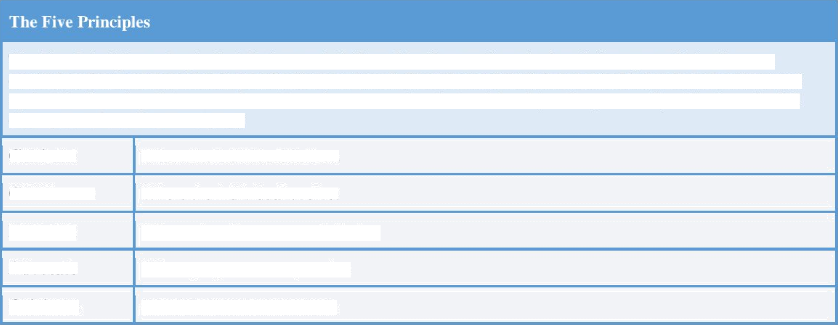
The Five Principles underpin the Mindsets and Skillsets Manifesto and are the foundation upon which dl course curriculum frameworks and unit specifications are based. The relevant Principles as stated below have been mapped against the Learning Outcomes relevant to each course unit and at each level (see Programme Specifications for full description of the Five Principles):
Cultivate
Where the individual thrives.
Collabora e
Integral
Advoca e
Where the individual evolve.
Where education engages industry.
Where purpose meets practice.
Ll›riginate
Creativity neets technology.

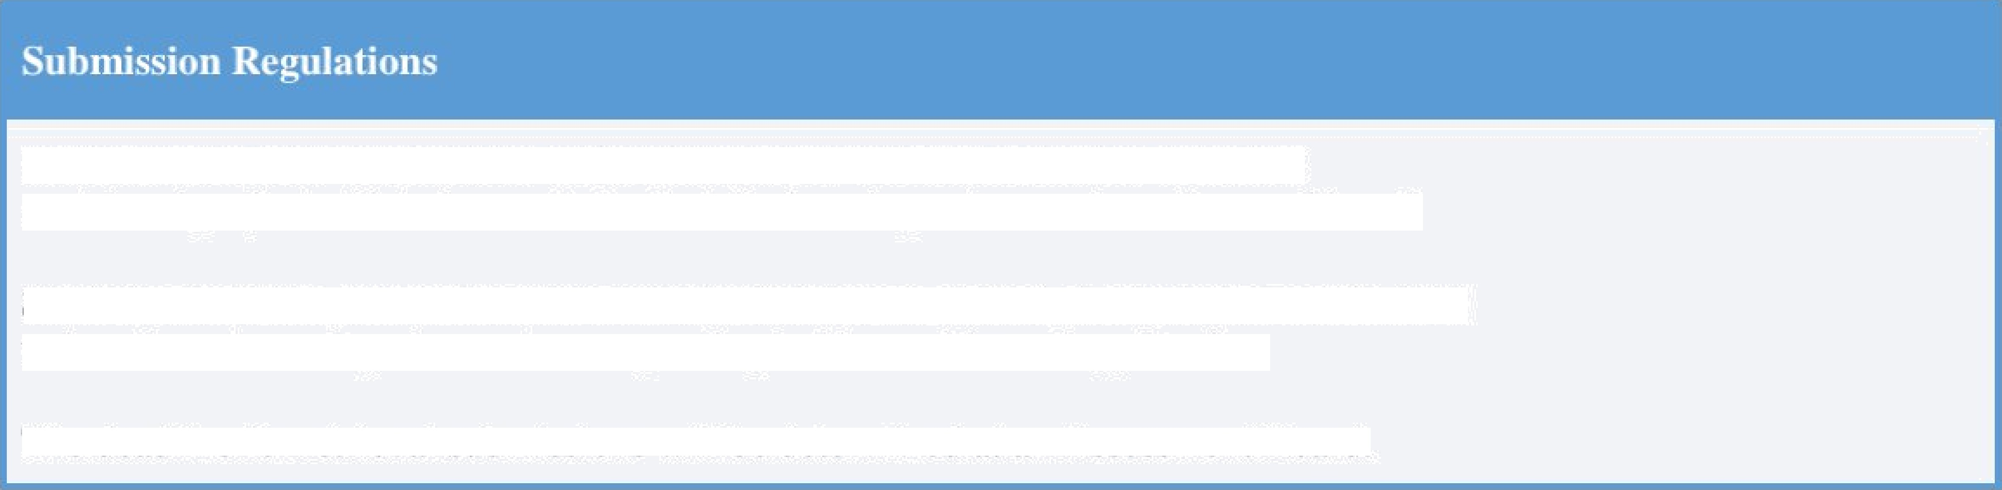
Sludents who miss the deadline or fail this projecl will be required to complete
a retrieval projeci which demonstrates that the learning outcomes have been achieved.
Students should be aware thal renieval submissions are capped at a bare pass grade, {D-)
unless the extenuating circumstances panel uphold an evidenced application.
The deadline for retrievd submissions will be determined at an Assessment Board.

